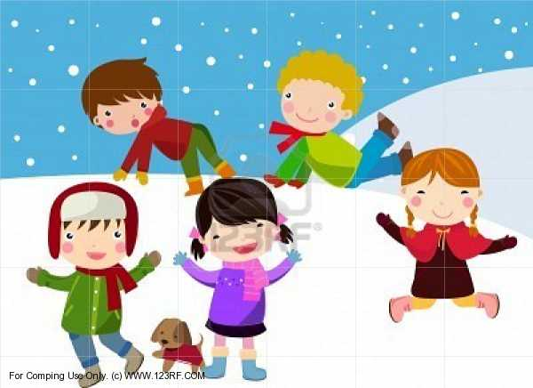
Published on: www.thejackandjillplaygroup.co.uk
Telephone: 01634 717585
E-mail: jackandjillplaygroup@hotmail.co.uk

JANUARY 2021

Dear PARENTS/CARERS

We do hope you all managed to have a happy Christmas break despite the restrictions and that you all remained safe and well.

The start to the new term is not what we would have wished for with the move into another National Lockdown, closure of schools and crises transmission rates within our own community. At this time, our pre-school remains open as directed by the government, your children may continue to attend as normal if everyone remains well.

May I emphasise the need for all families to follow the current guidelines some of which are legal obligations set by the government. If you are not prepared to follow guidelines and are socially mixing outside of any allowed bubbles, then please do not put our other families or us at risk by attending playgroup. Stay at home. We need our staff and children healthy to open and we all have families at home that need our protection.

I have included once again our guidelines for attendance which have been amended to reflect what we feel makes our provision safer for your child to attend.

We will continue to be vigilant to making our provision a healthy and safe place for your children, only healthy staff will work, we socially distance where possible from each other and will complete a test every 2 weeks and practitioners are expected to follow government guidelines and our procedures to keep themselves COVID safe while working for us. I ask you to remember that as an Early Years setting, we are not supported or funded to wear PPE, your children do not and cannot socially distance from us or their friends during play please keep this in mind and only send in your children if they are well.
COVID19 SAFETY GUIDELINES

AT THE GATE YOU MUST WEAR A FACE COVERING – parents/carers will be challenged, and we will not accept a child from a parent/carer unless a face covering is worn.

PARENT/CARER MUST SOCIALLY DISTANCE - remember when approaching the setting and queuing parents must socially distance from other parents, wear a mask and do not gather to chat when dropping off and picking up your child.

If you cannot do this then we may ask you not to bring your child until you are able to follow our guidelines.

STAFF MAY WEAR A FACE COVERING – when at the gate. Please do not engage in lengthy conversation with staff at gate to minimise contact, telephone or email the information you wish to share.

Staff may now choose to wear face-coverings when in close physical contact with children and other adults within the setting.

DO NOT send your child to playgroup if they have even minor ailments such as colds, coughs, runny noses sickness or diarrhoea, impetigo, conjunctivitis, chicken pox or any illness that requires medication, temperature control (Calpol).

IF IN ANY DOUBT that your child is at all poorly or not themselves please stay home or indeed any member of your household. If you have other children/siblings, adults that live with you and they have been asked to isolate (even if they do not have symptoms) that you do not send your child into our playgroup for the isolation period to reduce the risk of transmission into our provision.

ENSURE yourselves are healthy and well enough to pick up and drop off children, arriving and leaving promptly once your child is welcomed by staff.

INFORM US if your child has attended playgroup and if anyone in your household becomes unwell with symptoms of coronavirus however mild, they must not come to playgroup please stay at home for at least 10 days from the date the symptoms appear. Anyone with symptoms will be eligible for testing and this can be arranged via https://www.nhs.uk/ask-for-a-coronavirus-test or by calling 119.

All other household members who remain well, must stay at home, and not leave the house for 10 days. This includes anyone in your `support bubble`.

Children are presenting with mild symptoms.

SYMPTOMS

The most common symptoms of coronavirus are recent onset of:

- a new continuous cough
- a high temperature
- a loss of, change in, normal sense of taste or smell
If your child does develop symptoms, you can seek advice from the nhs.uk website at htts://www.nhs.uk/conditions/coronavirus-covid-19. If you are concerned about your child`s symptoms, or they are worsening you can seek advice from NHS111 at https://111.nhs.uk or by phoning 111.

If a child or staff member with symptoms tests positive, we will inform parents and manage confirmed cases of coronavirus in line with our current public health guidance and on advice from our designated local health protection team.

CLOSURE

The provision may be closed temporarily to isolate, if we have positive tests or an overall rise in sickness absence of children, or staff where COVID19 is suspected as this may indicate an outbreak.

We will share contact details of parents/carers and adult within our setting with the NHS Test and Trace service, if parents do not want to give permission for us to do this then we cannot offer your child a place at our setting during the COVID19 pandemic.

Please be assured we will do our absolute best to keep everyone safe within our playgroup family and that your children will be happy, continue to learn and kept while in our care.

All information such as notifications, newsletters and parents’ updates will be shared via telephone, emailed, or texted.

WE WOULD LIKE TO THANK ALL PARENTS AND YOUR FAMILIES FOR YOUR CONTINUED SUPPORT TO KEEP OUR PLAYGROUP A SAFE PLACE

DELIA AND SALLY
MANAGERS
ON AND BEHALF OF THE
PLAYGROUP COMMITTEE

